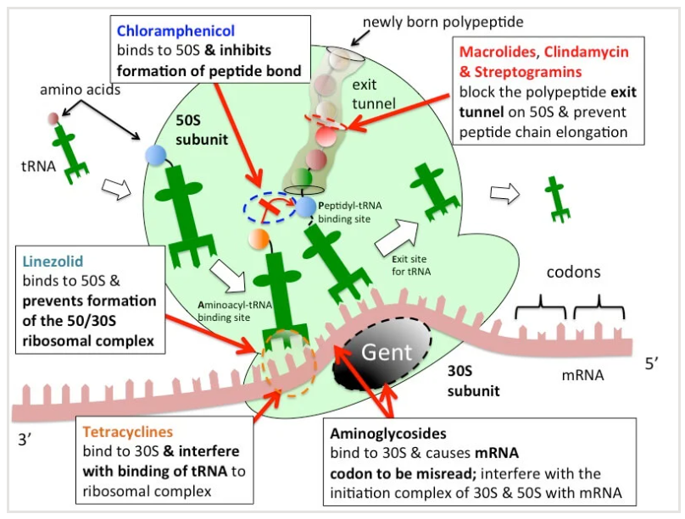
Protein Synthesis Inhibitors

Introduction
Protein synthesis inhibitors represent a vital class of antimicrobial agents. They function by "targeting bacterial protein production," interfering with the essential processes bacteria need to build proteins, which are fundamental for their growth, replication, and survival.

Chloramphenicol
Chloramphenicol is a potent antibiotic with historical significance, first isolated in 1947 from Streptomyces venezuelae. Its use is now "limited due to its toxicity profile," reserved for "severe infections that cannot be treated with other drugs, often in patients who have allergies or sensitivities."

Mechanism of Action
Chloramphenicol "binds to the 50S ribosomal subunit," a key component of the bacterial 70S ribosome. This binding prevents aminoacyl tRNA from attaching to the acceptor site, thereby "disrupt[ing] the formation of peptide bonds between amino acids (the essential step in protein synthesis)." It specifically inhibits "peptidyl transferase."
- Notably, it shows "limited ability to inhibit protein synthesis in eukaryotic cells," except for mitochondria, due to similarities in their ribosomal structure (both 70S).

Resistance Mechanisms
Resistance to chloramphenicol can arise through several mechanisms:
- Plasmid-encoded acetyltransferases: These enzymes "modify the drug's structure, rendering it inactive."
- Decreased permeability: Alterations in the bacterial cell membrane can "reduce chloramphenicol's entry into the cell."
- Ribosomal mutations: Genetic changes within bacterial ribosomes can lead to resistance.

Pharmacokinetics
- Absorption: Readily absorbed by bacterial cells via facilitated diffusion. Available orally as an active drug or inactive prodrug (chloramphenicol palmitate). The water-soluble sodium succinate formulation is preferred for intravenous use.
- Distribution: "Wide distribution throughout the body," cross the placenta and blood-brain barrier.
- Metabolism & Elimination: Primarily metabolized in the liver to an inactive glucuronide metabolite, which is then excreted via urine.

Therapeutic Uses
Chloramphenicol is reserved for specific, severe infections:
- Typhoid Fever: A backup option when other antimicrobials are inadequate.
- Bacterial Meningitis: Used for patients resistant or allergic to beta-lactam antibiotics.
- Rickettsial Diseases: Such as Rocky Mountain spotted fever.
- Eye Infections: Topical applications are effective for conditions like conjunctivitis.

Adverse Effects
The most significant side effect is hematologic toxicity, particularly bone marrow suppression:
- Dose-Dependent Toxicity: Leads to a decline in blood cell counts (anemia, leukopenia, thrombocytopenia), resulting in pancytopenia, especially with prolonged or repeated exposure.
- Non-Dose-Related Toxicity: Manifests as "aplastic anemia, a rare but severe complication," which "may be caused by non-dose-related factors such as a hypersensitivity reaction or an idiosyncratic response." The risk of aplastic anemia does not contraindicate its use when necessary, but "the drug should never be employed in unclear situations or in diseases effectively treatable with other antimicrobial agents."
- Hemolysis and Jaundice: Rare but severe reactions.
- Gray Baby Syndrome: A "severe but uncommon side effect primarily affects infants and neonates," occurring 2-9 days after treatment. Symptoms include vomiting, irregular breathing, abdominal distension, and greenish stool. It is caused by the neonate's "inadequate activity of glucuronyl transferase in the liver (develop in first 3-4 week of life)" and "inadequate renal excretion of unconjugated drug."
- Hypersensitivity Reactions: Rare, presenting as macular or vesicular skin rashes with fever.
- Pregnancy & Breastfeeding: Classified as Category D, posing a potential risk to the fetus and passing into breast milk.

Drug Interactions
Chloramphenicol can "inhibit cytochrome P450 enzymes," leading to "prolonged half-lives for other drugs metabolized by the same system" (e.g., dicumarol, phenytoin, and tolbutamide). Conversely, drugs like phenobarbital and rifampin can "shorten the half-life of the antibiotic."

Forms Available
Available as injectable (IV) of 1g solution, eye drops (1% w/v and 0.5% w/v), eye ointment (1% w/w or 0.5% w/w), syrup/suspensions (125 mg per 5 ml), and topical ointments (0.3% w/w and 0.5% w/w).

Tetracyclines
Tetracyclines are a "broad-spectrum bacteriostatic antibiotics known for their efficacy against a wide range of bacteria."

General Characteristics
- Mechanism of Action: They "bind to the 30S ribosomal subunit of bacteria, preventing the attachment of aminoacyl-tRNA molecules to the ribosome." This halts peptide bond formation and protein synthesis.
- Spectrum of Activity: Broad, including Gram-positive (e.g., S. aureus, S. pyogenes, S. pneumoniae, B. anthracis) and Gram-negative bacteria (e.g., E. coli, Salmonella, Shigella, Proteus mirabilis). They are particularly effective against "intracellular pathogens like Rickettsia and Chlamydia."

Major Tetracycline Classes and Examples

Tetracycline
The parent drug.
- Pharmacokinetics: Well absorbed orally. Absorption can be affected by food and multivalent cations (calcium, iron, aluminum).
- Clinical Applications: Broad-spectrum antibiotic, effective against Mycoplasma, Rickettsia, Chlamydia, E. coli, S. aureus, S. pyogenes. Also has antiparasitic activity for Lyme disease and malaria.
- Adverse Effects: Oral absorption issues, and "Tetracycline-Induced Staining" of teeth and permanent dentin in children, causing "irreversible discoloration."

Minocycline (minocycline hydrochloride)
- Pharmacokinetics: Highly bioavailable orally, longer half-life than tetracycline.
- Clinical Applications: Effective against diverse bacterial infections including acne, Lyme disease, pneumonia. Its epithelial penetration makes it useful for skin conditions.

Doxycycline (Biliary excretion)
A tetracycline derivative with high oral bioavailability.
- Pharmacokinetics: Rapid oral absorption, highly bioavailable, metabolized primarily in the liver, excreted through bile.
- Clinical Applications: Broad-spectrum, effective against Mycoplasma, Rickettsia, Chlamydia, and acne.

Adverse Effects of Tetracyclines (General)
- Gastrointestinal Side Effects: Nausea, vomiting, diarrhea, stomachaches, especially at higher doses.
- Photosensitivity: Increased risk of sunburn or skin reactions.
- Chelation: Can bind to calcium, potentially leading to hypocalcemia.
- Teeth Staining: "Permanent" staining, a major concern for children and pregnant women.
- Drug Interactions: Reduced absorption with calcium-containing supplements, antacids, and iron supplements.

Clinical Applications and Indications (General)
- Acne Treatment: Topical doxycycline.
- Lyme Disease Treatment: Highly effective, especially in early stages.
- Rocky Mountain Spotted Fever: Caused by Rickettsia rickettsii.
- Other Infections: Pneumonia, chlamydial infections.
Important Considerations
- Pregnancy and Breastfeeding: Tetracyclines "can cross the placenta and pass into breast milk, posing potential risks for infants."
- Children: Generally avoided due to impact on dental health.

Oxazolidinones

Linezolid
A crucial antibiotic against "multidrug-resistant Gram-positive bacteria," including MRSA and VRE.
- Mechanism of Action: Binds to a "unique region on the 23S ribosomal RNA within the 50S subunit, known as the P site, preventing formation of the larger ribosome-fMet-tRNA complex," thus inhibiting the initiation of protein synthesis. Primarily bacteriostatic, but can be bactericidal against Streptococcus species.
- Pharmacokinetics: High oral bioavailability (100%), short half-life (4-6 hours). Does not affect cytochrome P450 enzymes.
- Clinical Uses:
  - Vancomycin-Resistant Infections (Enterococcus faecium).
  - Hospital-Acquired and Community-Acquired Pneumonia.
  - Skin and Soft Tissue Infections (SSTIs) caused by susceptible bacteria, including MRSA.
  - Nocardia infections.
- Side Effects:
  - Hematologic Toxicity: Thrombocytopenia, neutropenia, and anemia, especially in patients with compromised bone marrow.
  - Central Nervous System Side Effects: Optic neuropathy, peripheral neuropathy, and lactic acidosis, primarily with prolonged use.

Tedizolid
A "next-generation oxazolidinone" with potential advantages over linezolid.
- Potency: Higher potency against MRSA and other Gram-positive bacteria.
- Safety Profile: Potentially "minimizes the risk of marrow suppression compared to linezolid."
- Pharmacokinetics: Longer half-life (12 hours) and higher protein binding (70-90%).

Lincosamines
Lincosamines, including Lincomycin and Clindamycin, inhibit bacterial protein synthesis by "binding to a specific site on the 50S ribosomal subunit, preventing the formation of peptide bonds." Their receptor on the 50S subunit is 23S rRNA.

Pharmacokinetics (ADME)
- Penetrates well into most tissues, abscesses, and is concentrated by phagocytic cells.
- Clindamycin is metabolized by the liver, both active drug and metabolites excreted in bile and urine.
- "No dosage adjustment is required for renal failure."

Spectrum of Activity
Broad spectrum against Gram-positive, some Gram-negative organisms (anaerobic). H. influenzae, Neisseriae, and Mycoplasma are usually resistant. Gram-negative aerobic species are intrinsically resistant due to poor outer membrane permeability.

Clinical Uses
- Infections originating in the female genital tract (e.g., septic abortion, pelvic abscesses).
- Aspiration pneumonia.
- Prophylaxis of endocarditis in patients with valvular heart disease undergoing dental procedures (recommended over erythromycin).
- Staph. Conjunctivitis (eye drops).
- Diabetic foot infections.
- Acne (1% topical gel & lotion).

Adverse Effects
- Hepatic toxicity: Rare, but possible with prolonged use.
- Neutropenia: Lower-than-normal white blood cell count.
- Antibiotic-Associated Colitis (AAC) / Diarrhea (0.1-10%): The "most serious concerning one and often requires discontinuation of therapy." This occurs when antibiotics disrupt beneficial gut bacteria, allowing opportunistic pathogens, particularly Clostridium difficile (C. diff), to flourish. C. diff produces necrotizing toxins that damage sigmoid colon cells, leading to inflammation and pseudomembranous (thick, inflamed membrane) colitis (PMC). Penicillin is also known to increase the risk of C. diff infection.

